Activity: Create an Amazon S3 Bucket
Objective
To create a new S3 bucket using the AWS Management Console.

Steps to Perform
Step 1: Login to AWS
- Open a web browser.
- Go to: https://aws.amazon.com/
- Click Sign In to the Console.
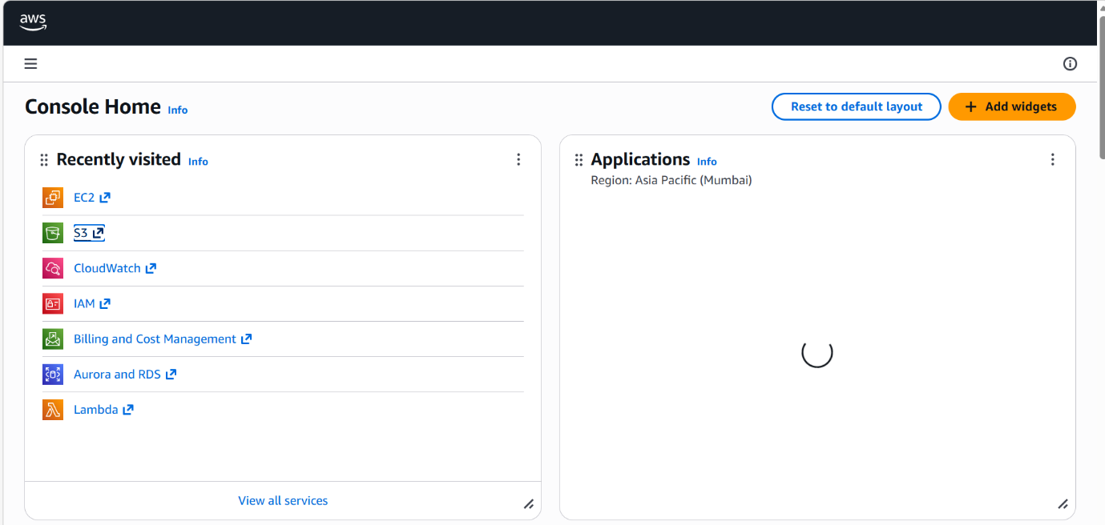
- Enter your AWS Username and Password.

Step 2: Open S3 Service
- After login, you will see the AWS Dashboard.
- In the search bar at the top, type S3.
- Click on S3 (Simple Storage Service).
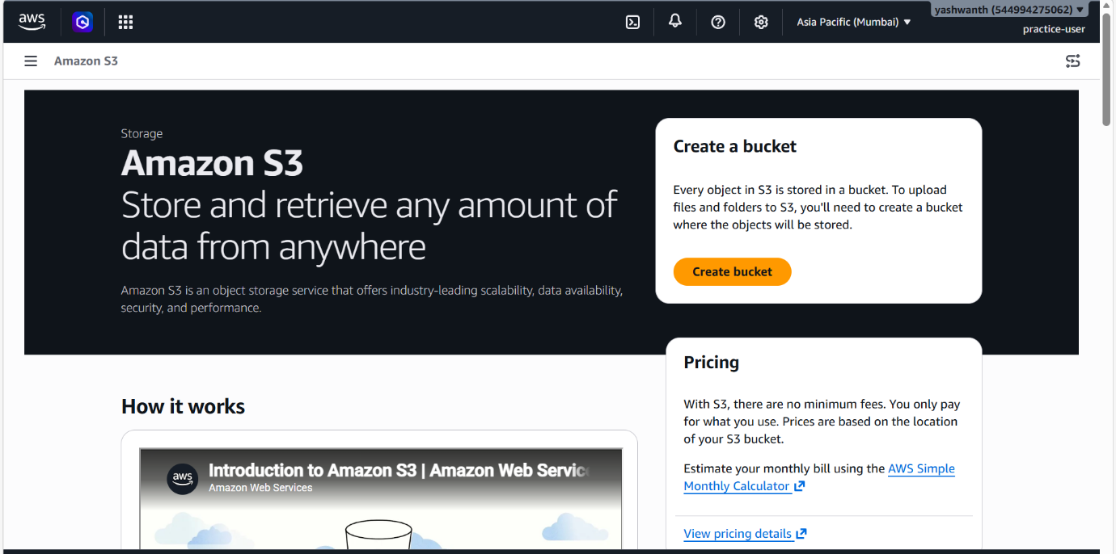

Step 3: Start Bucket Creation
- Click on the Create bucket button.
- The bucket creation page will open.
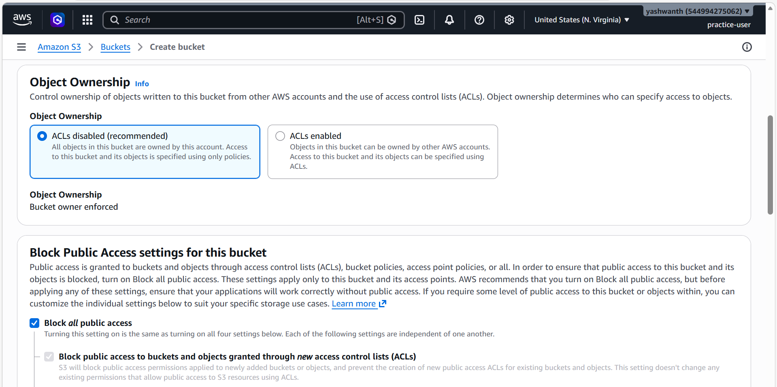

Step 4: Enter Bucket Details
- In Bucket name, enter a unique name
👉 Example: my-s3-bucket-2026
- Choose a Region (select closest location for better performance).
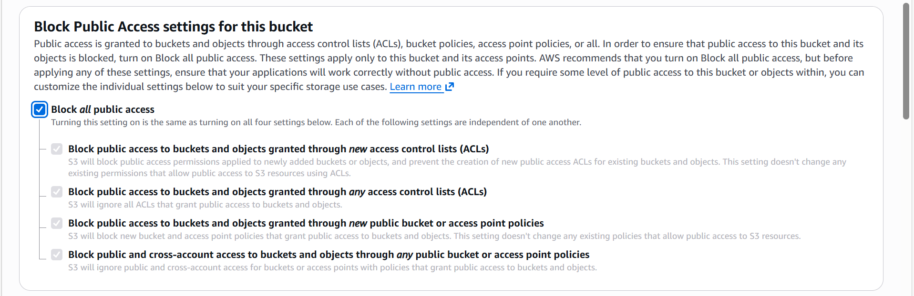

Step 5: Configure Settings
- Leave Object Ownership as default.
- Under Block Public Access:
  - Keep all options enabled (recommended for security).
- Scroll down (keep default settings for now).
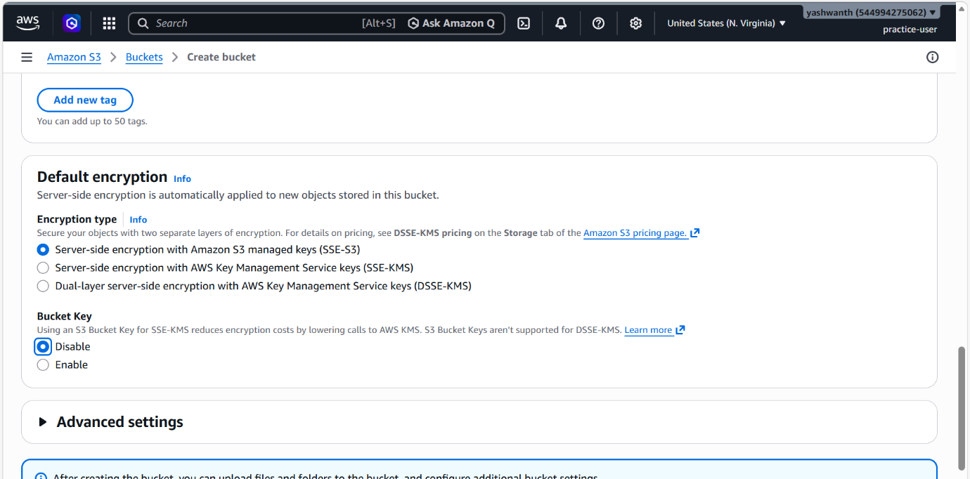
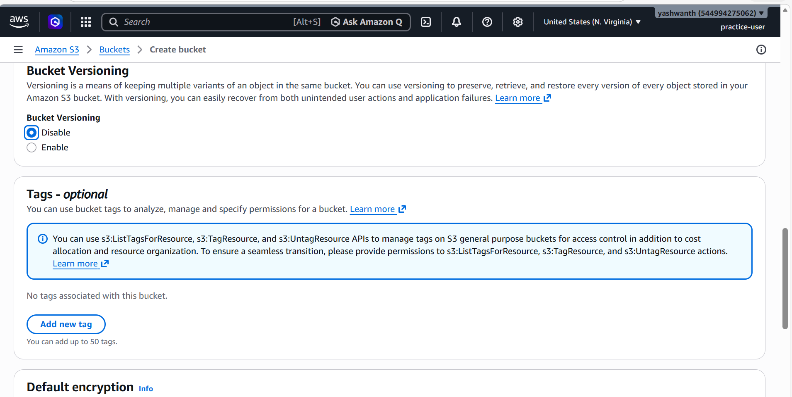

Step 6: Review and Create
- Review all the settings.
- Click on Create bucket.

✅ Outcome / Result
- The S3 bucket is successfully created.
- It will appear in your S3 bucket list.
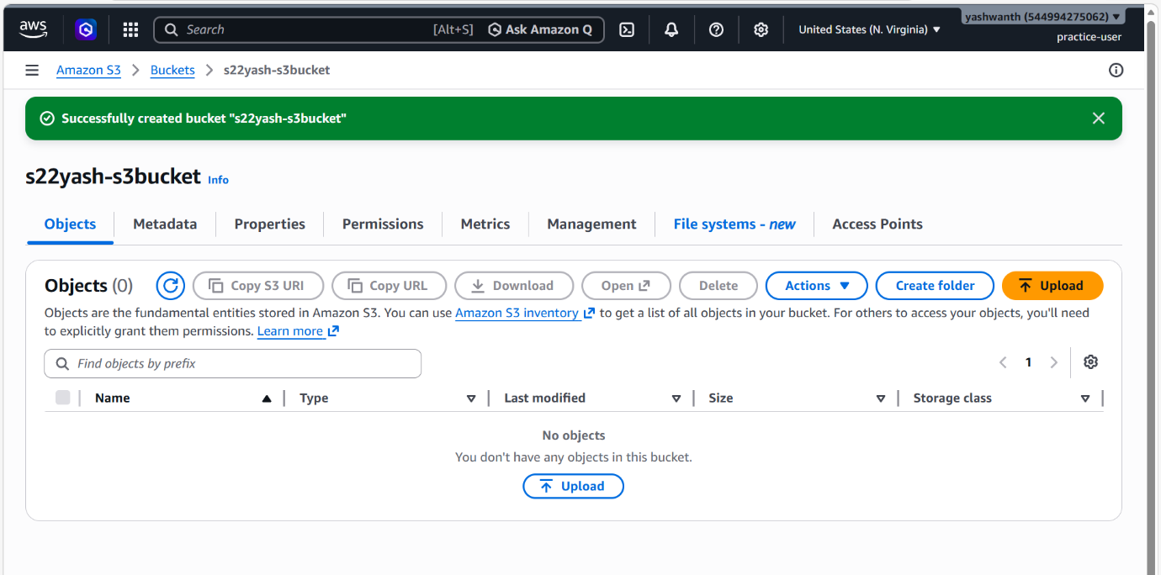

Verification Step
- Click on the bucket name.
- Confirm that the bucket opens successfully.

Conclusion
You have successfully created an S3 bucket in AWS using the Management Console.

